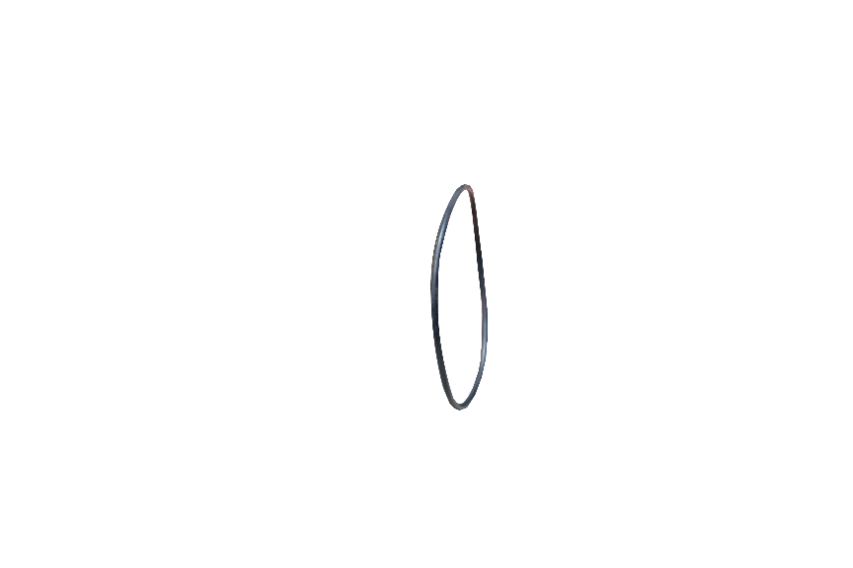
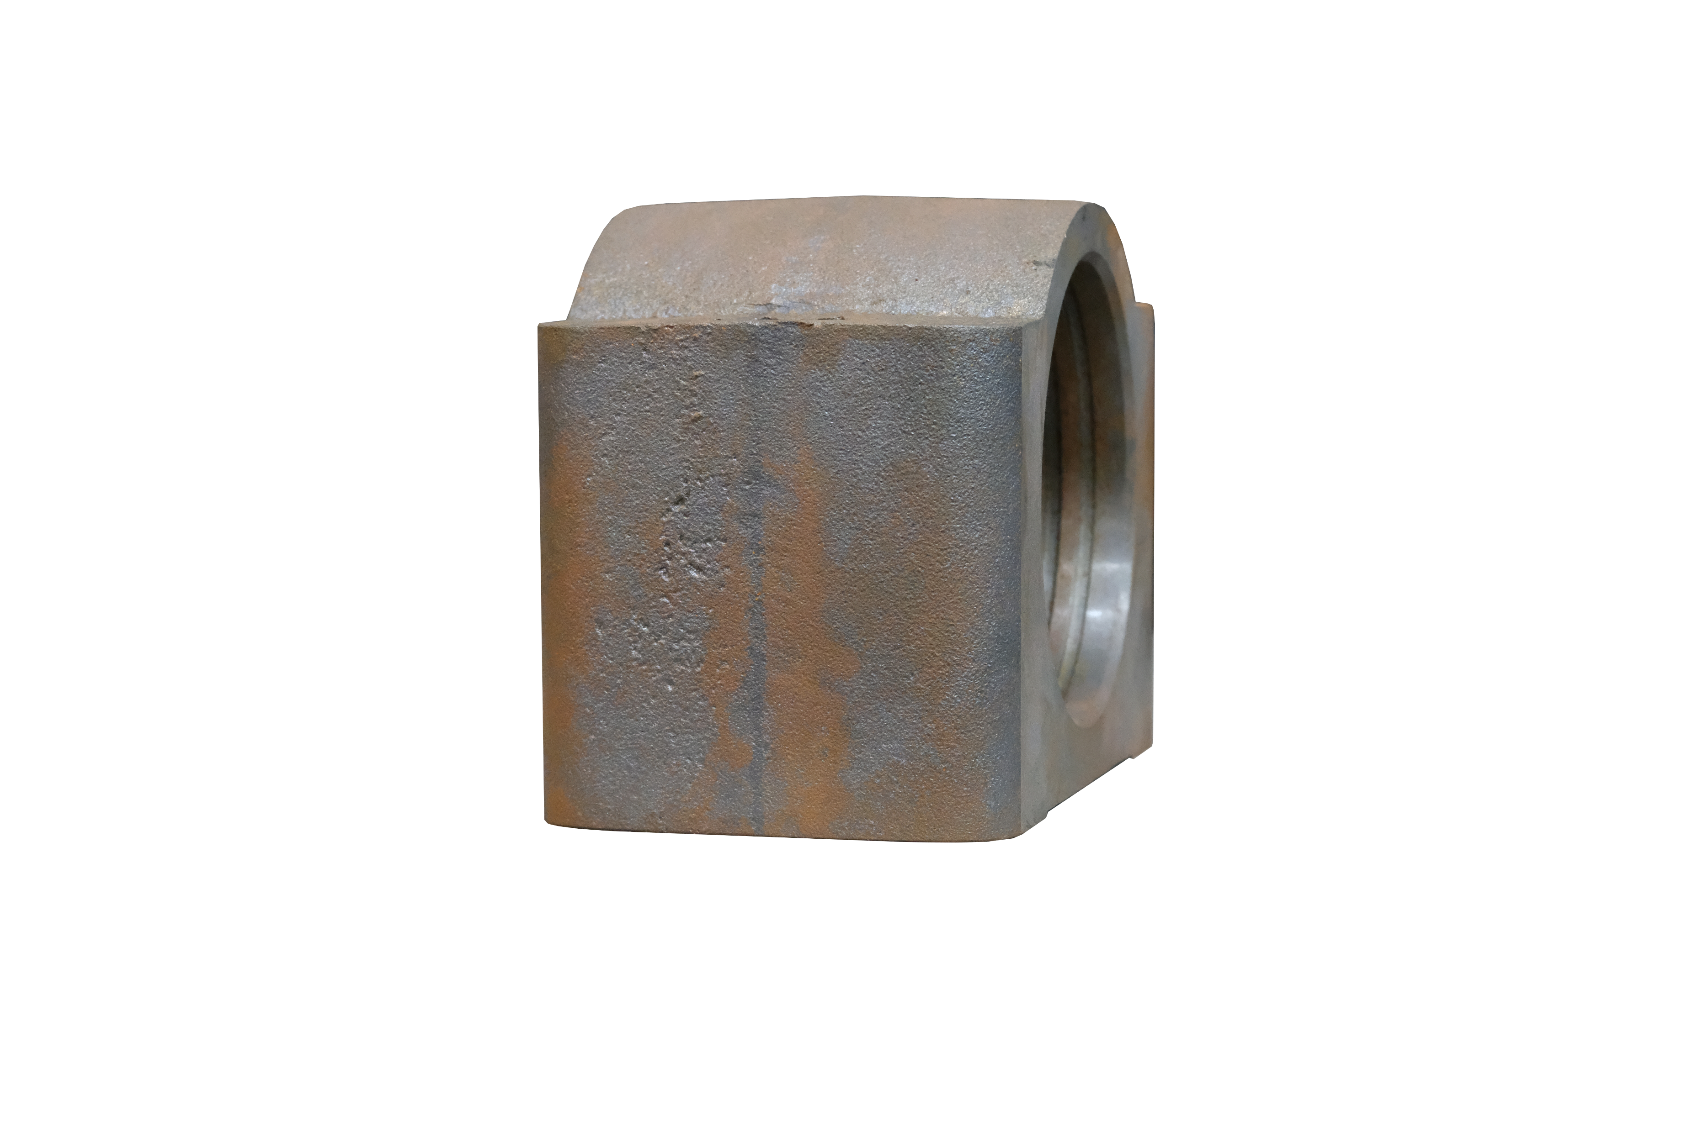
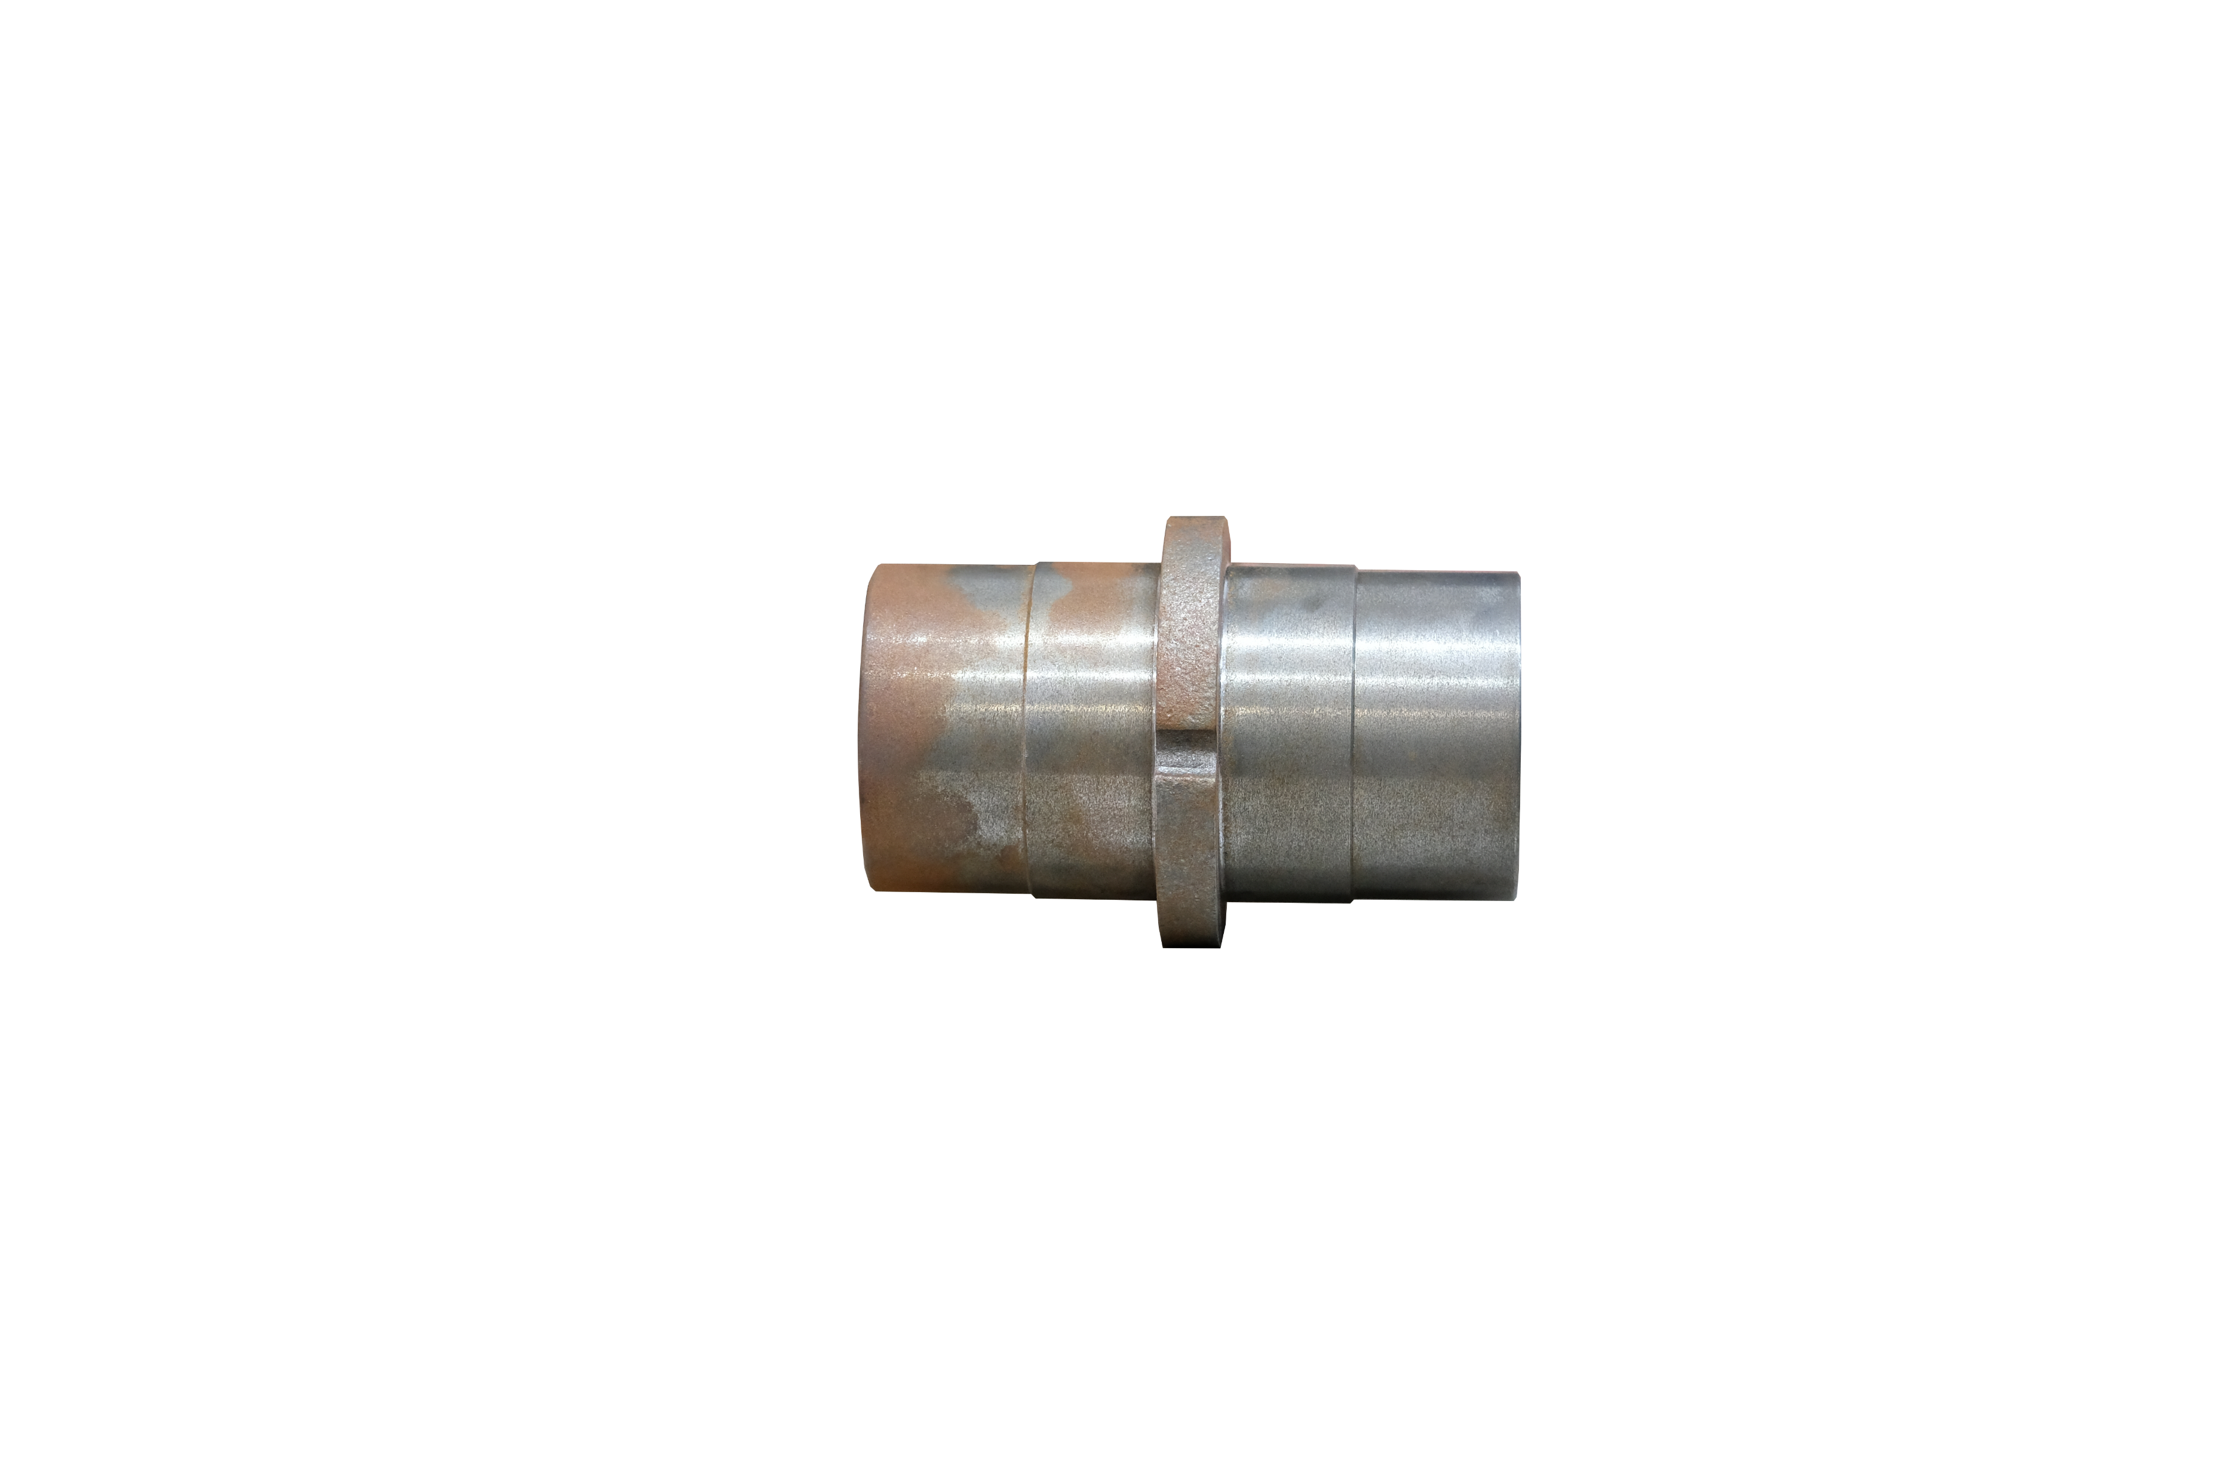
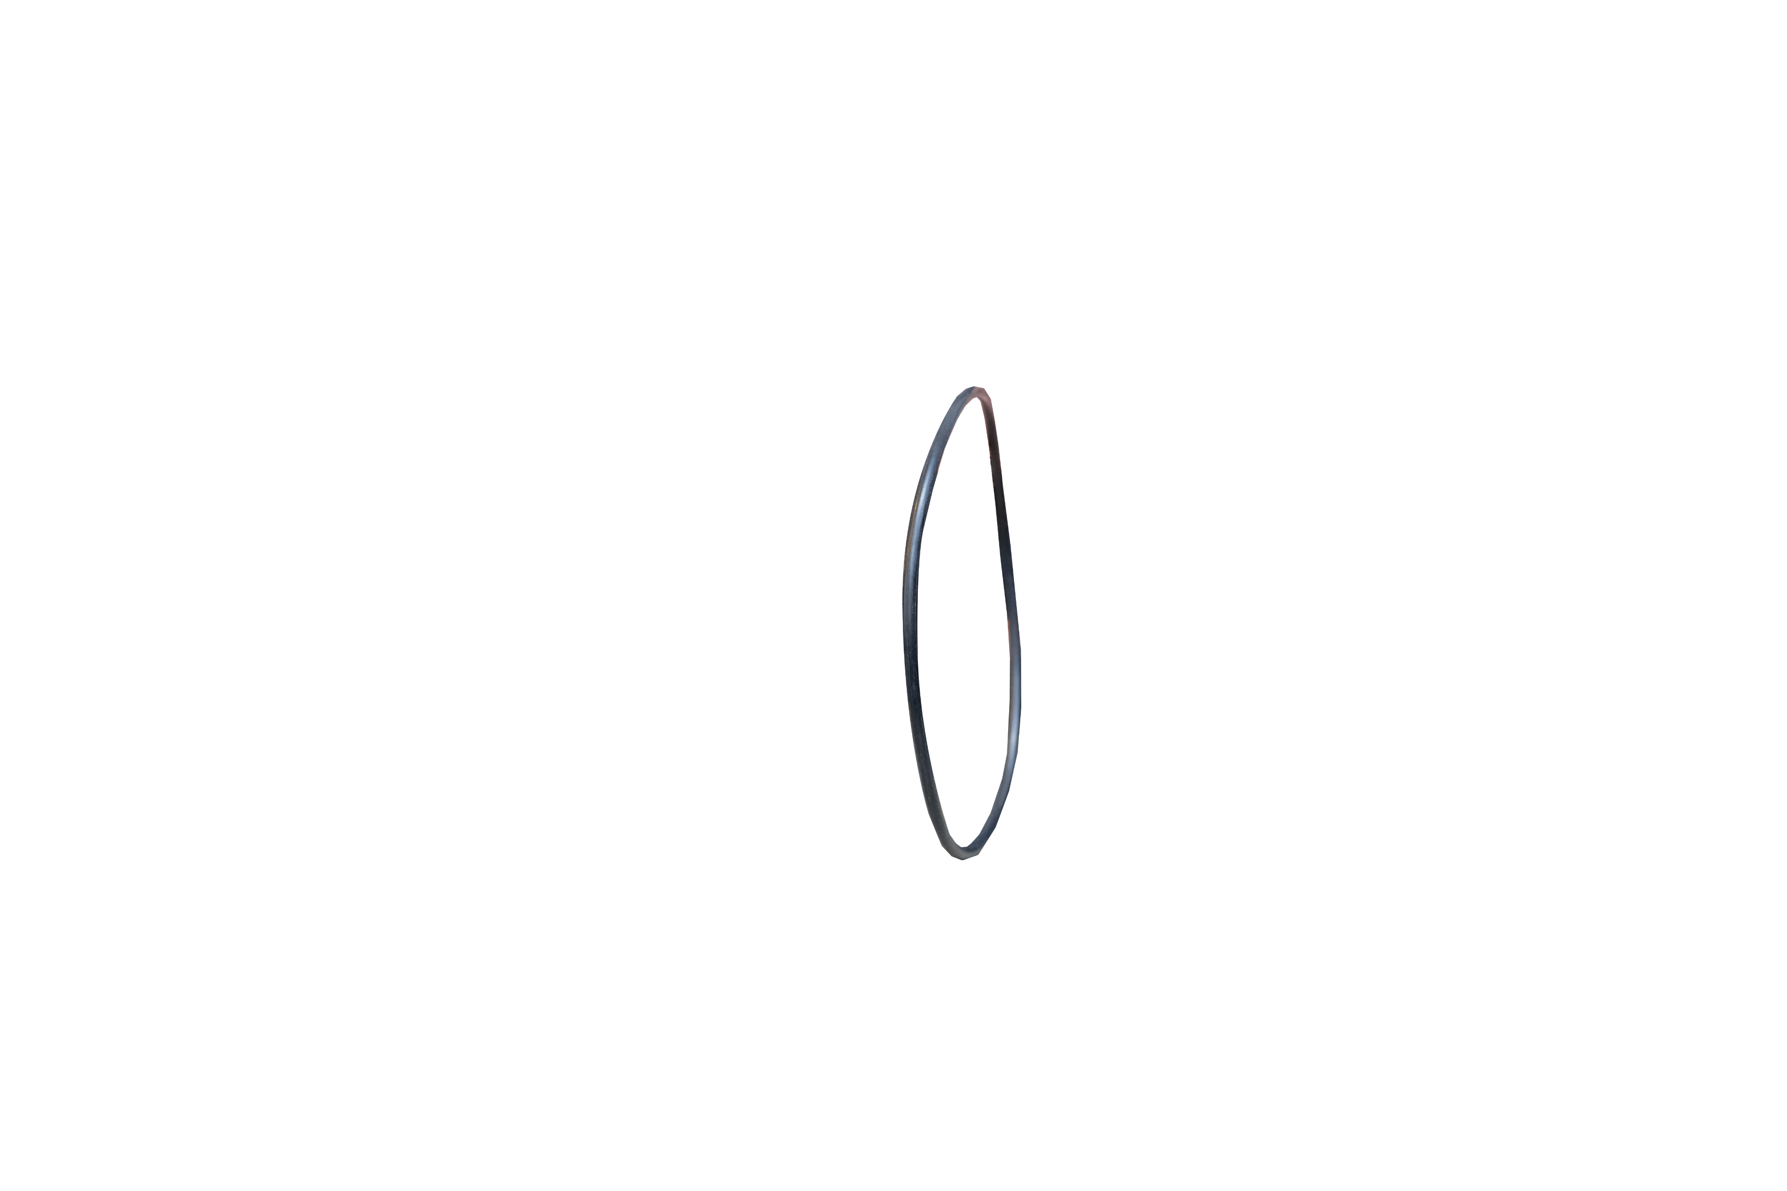
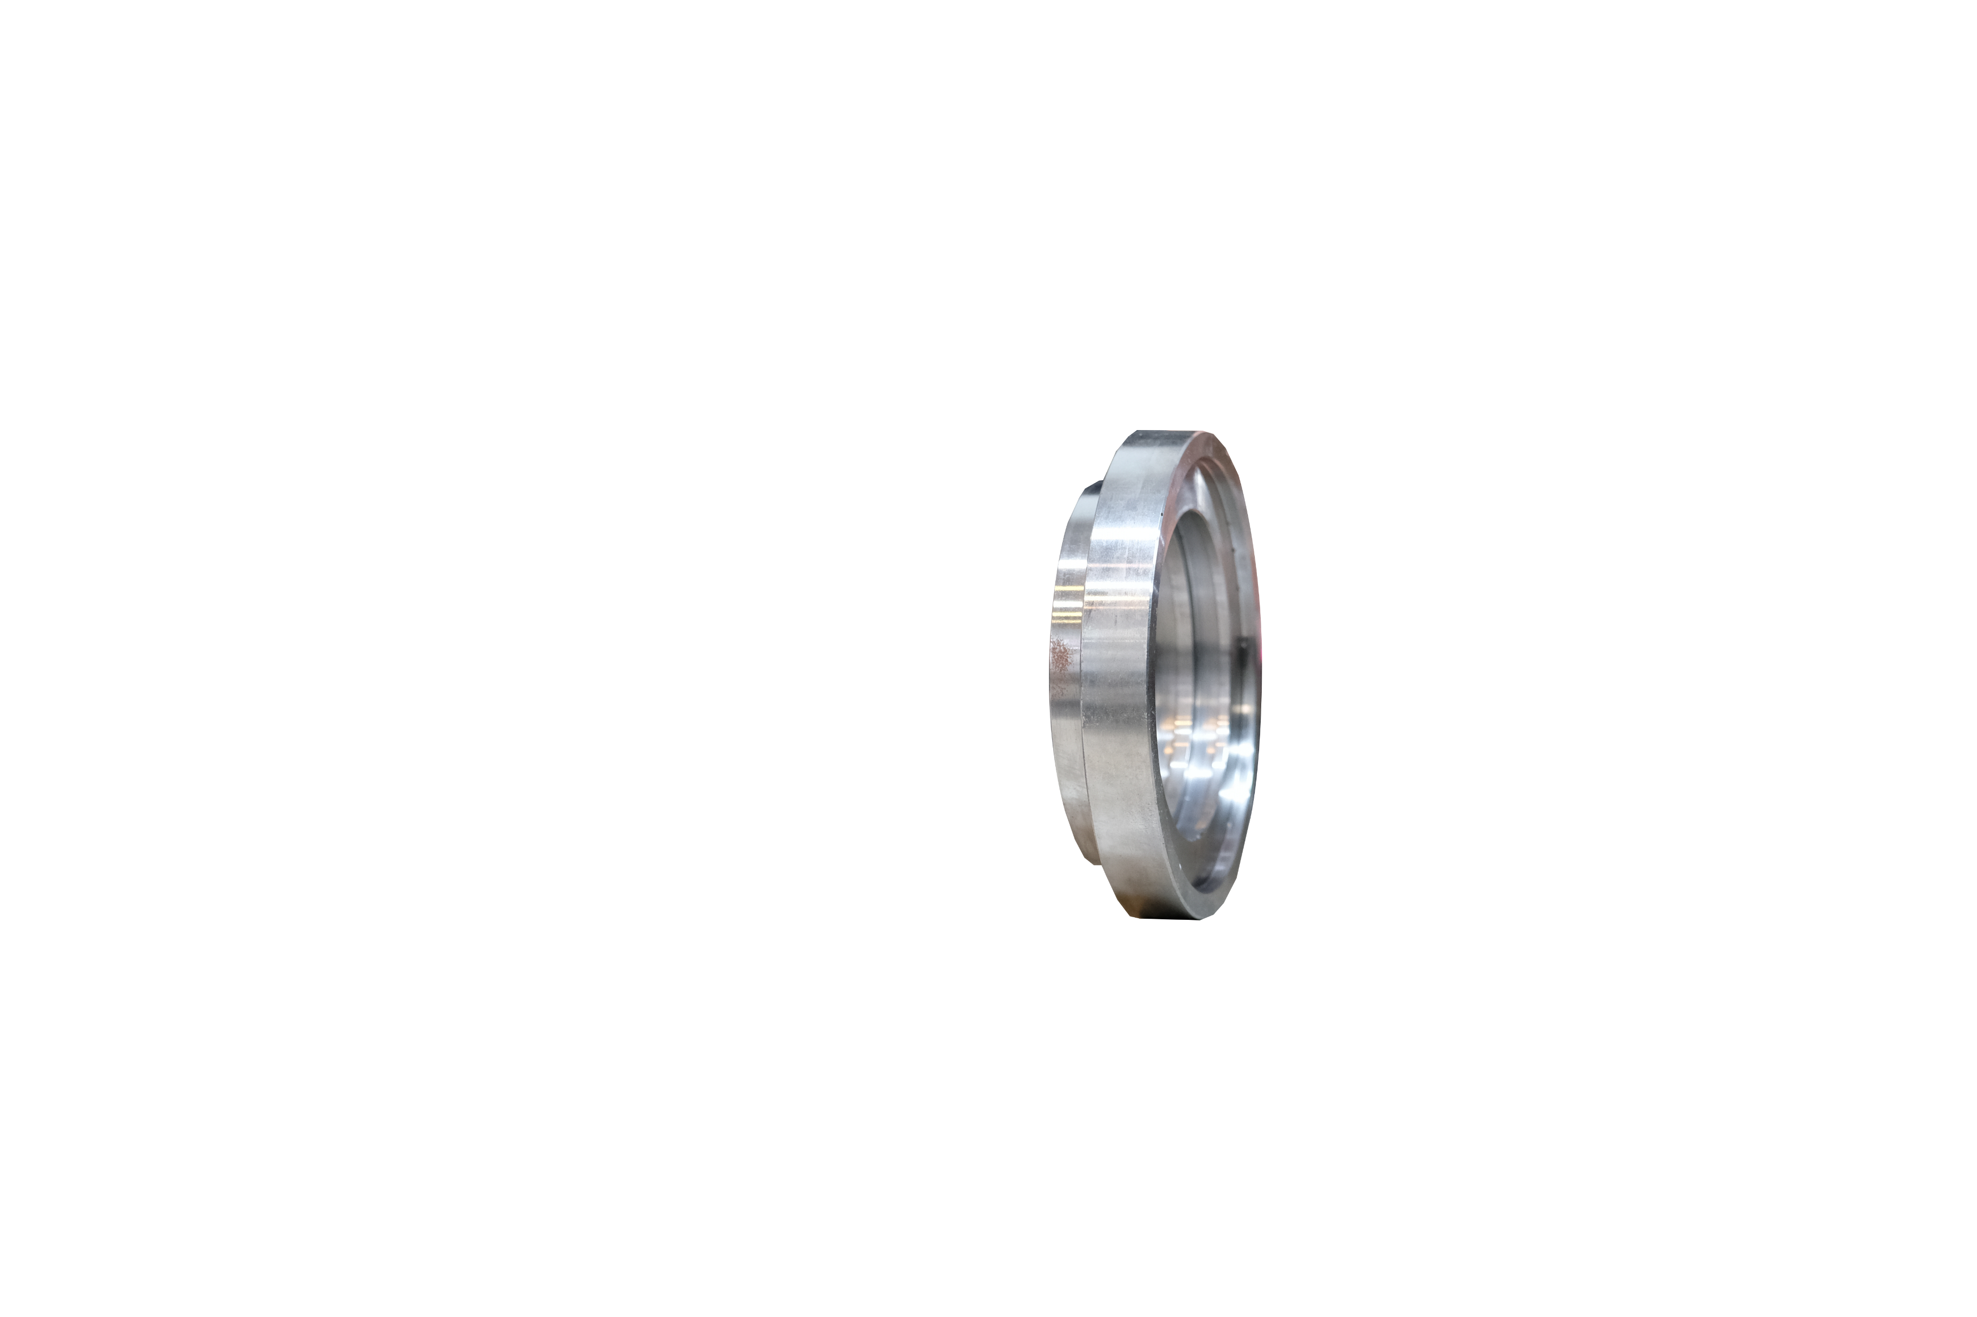
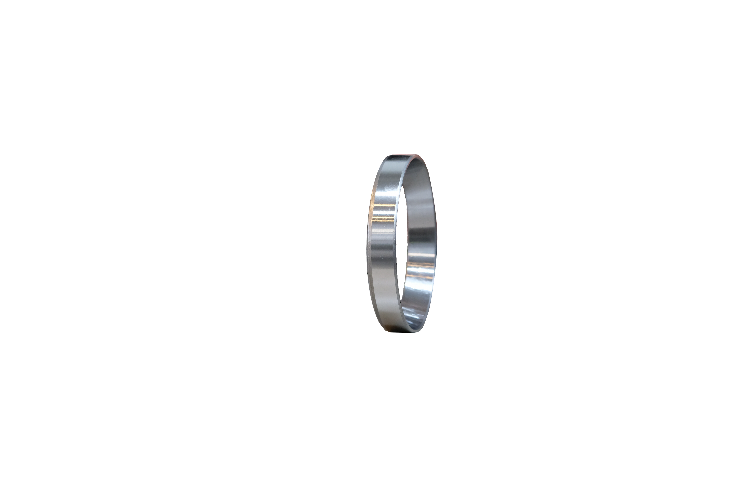
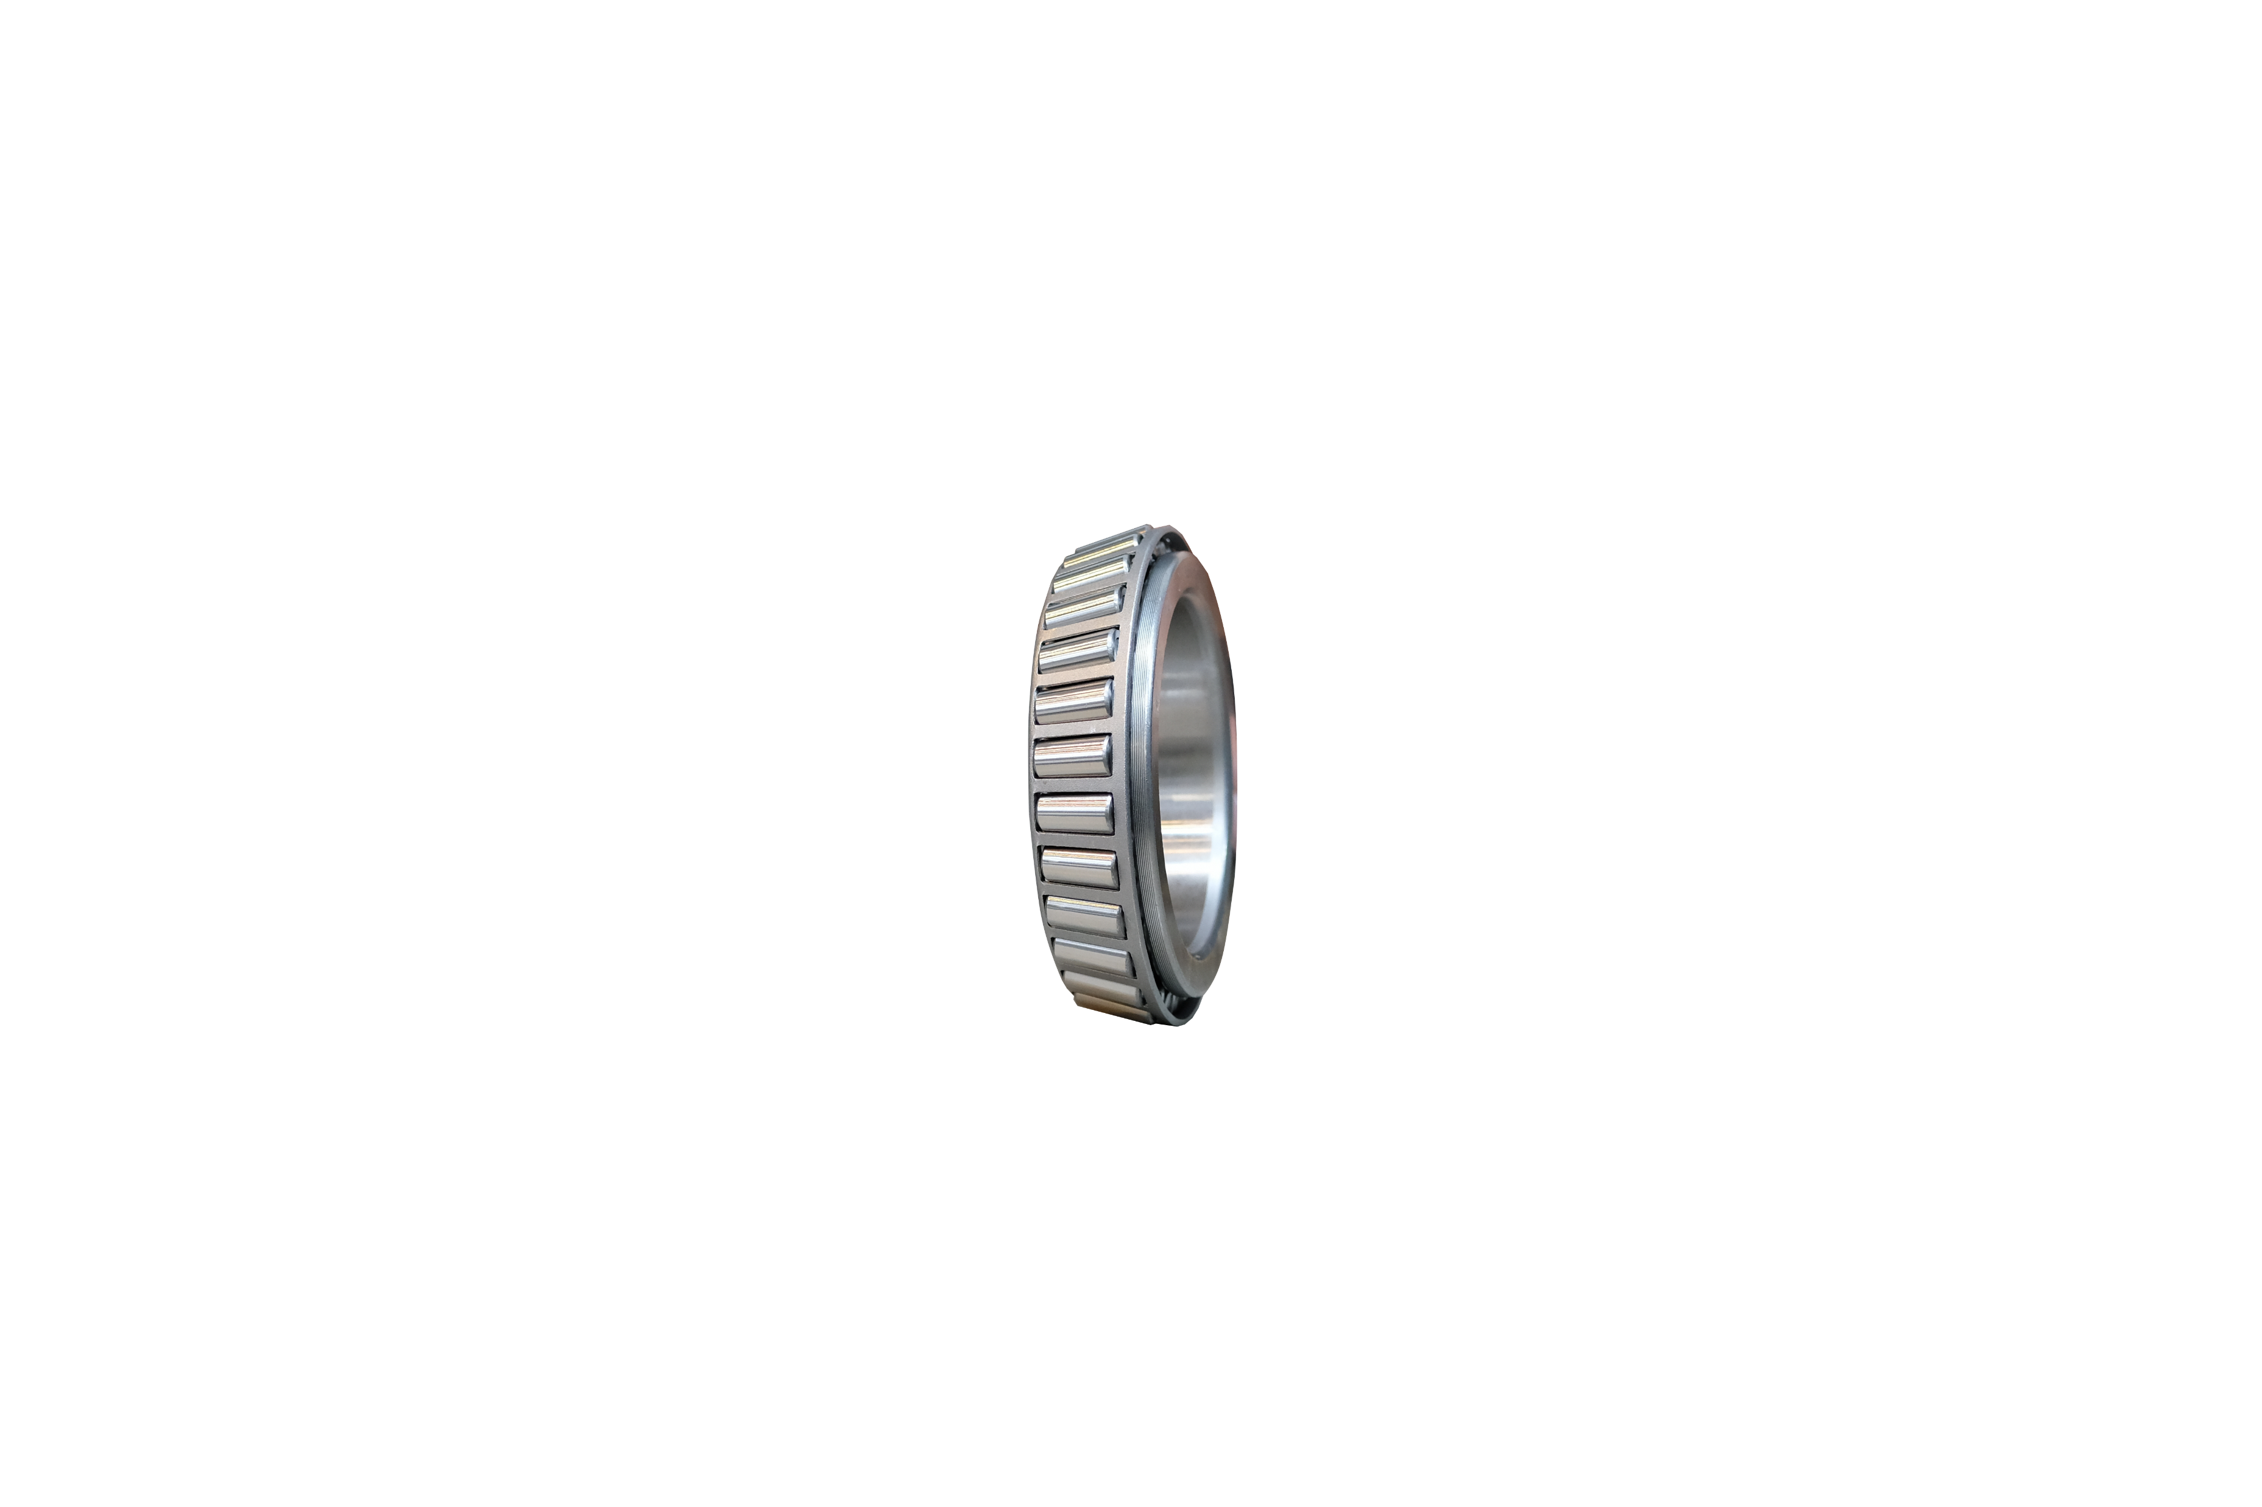
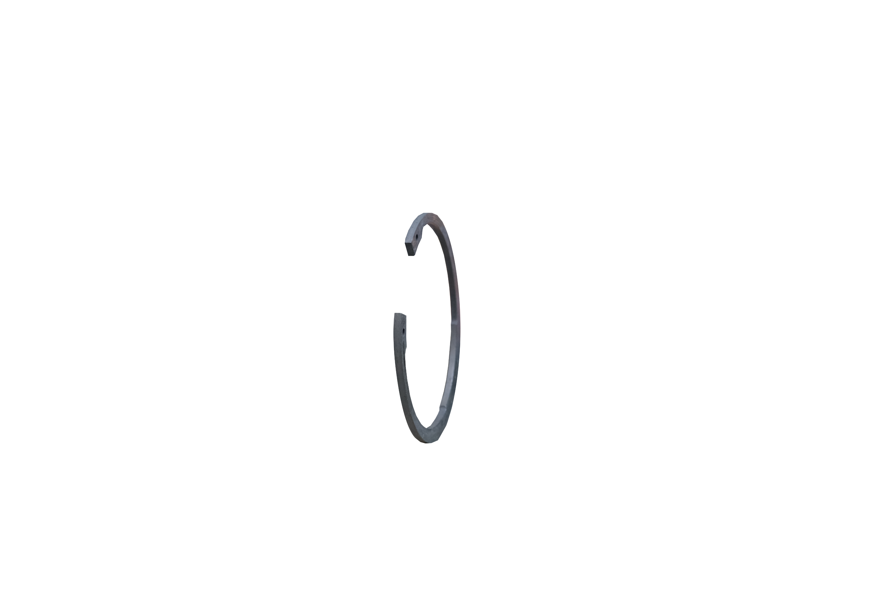
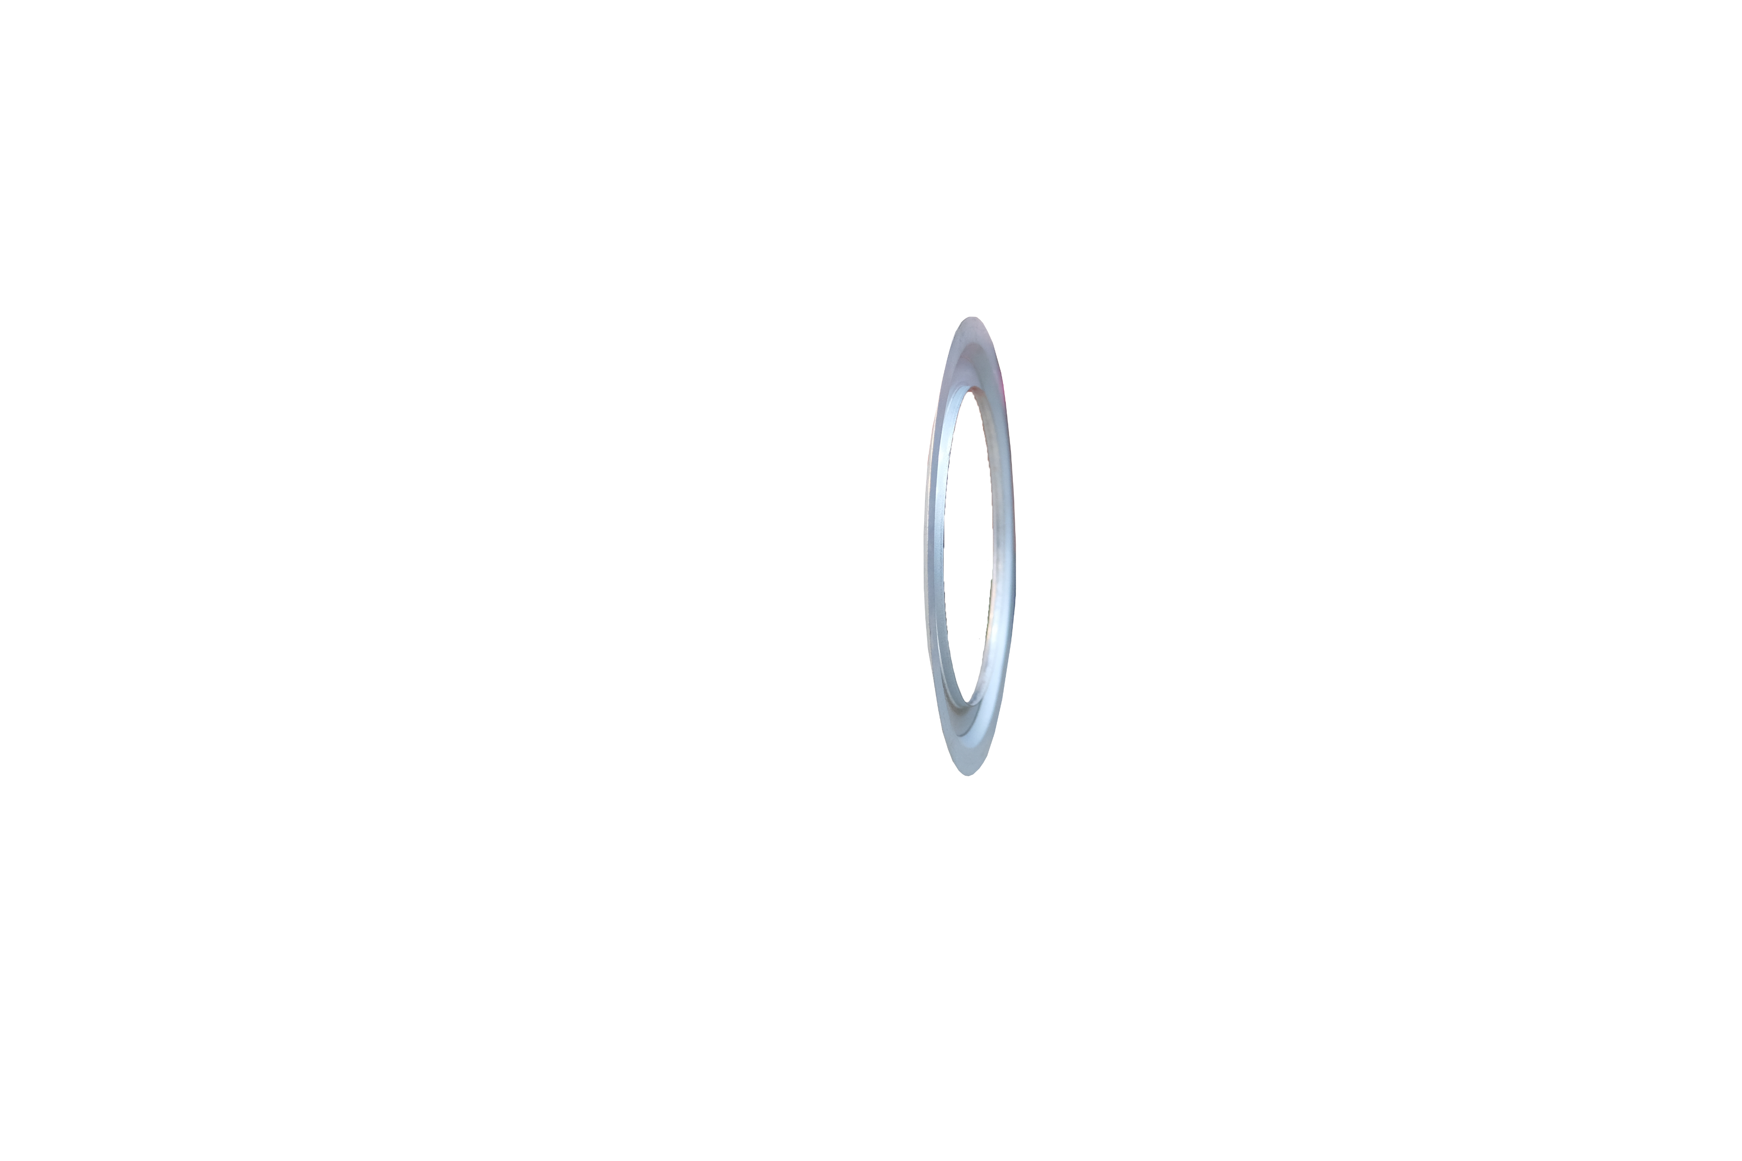
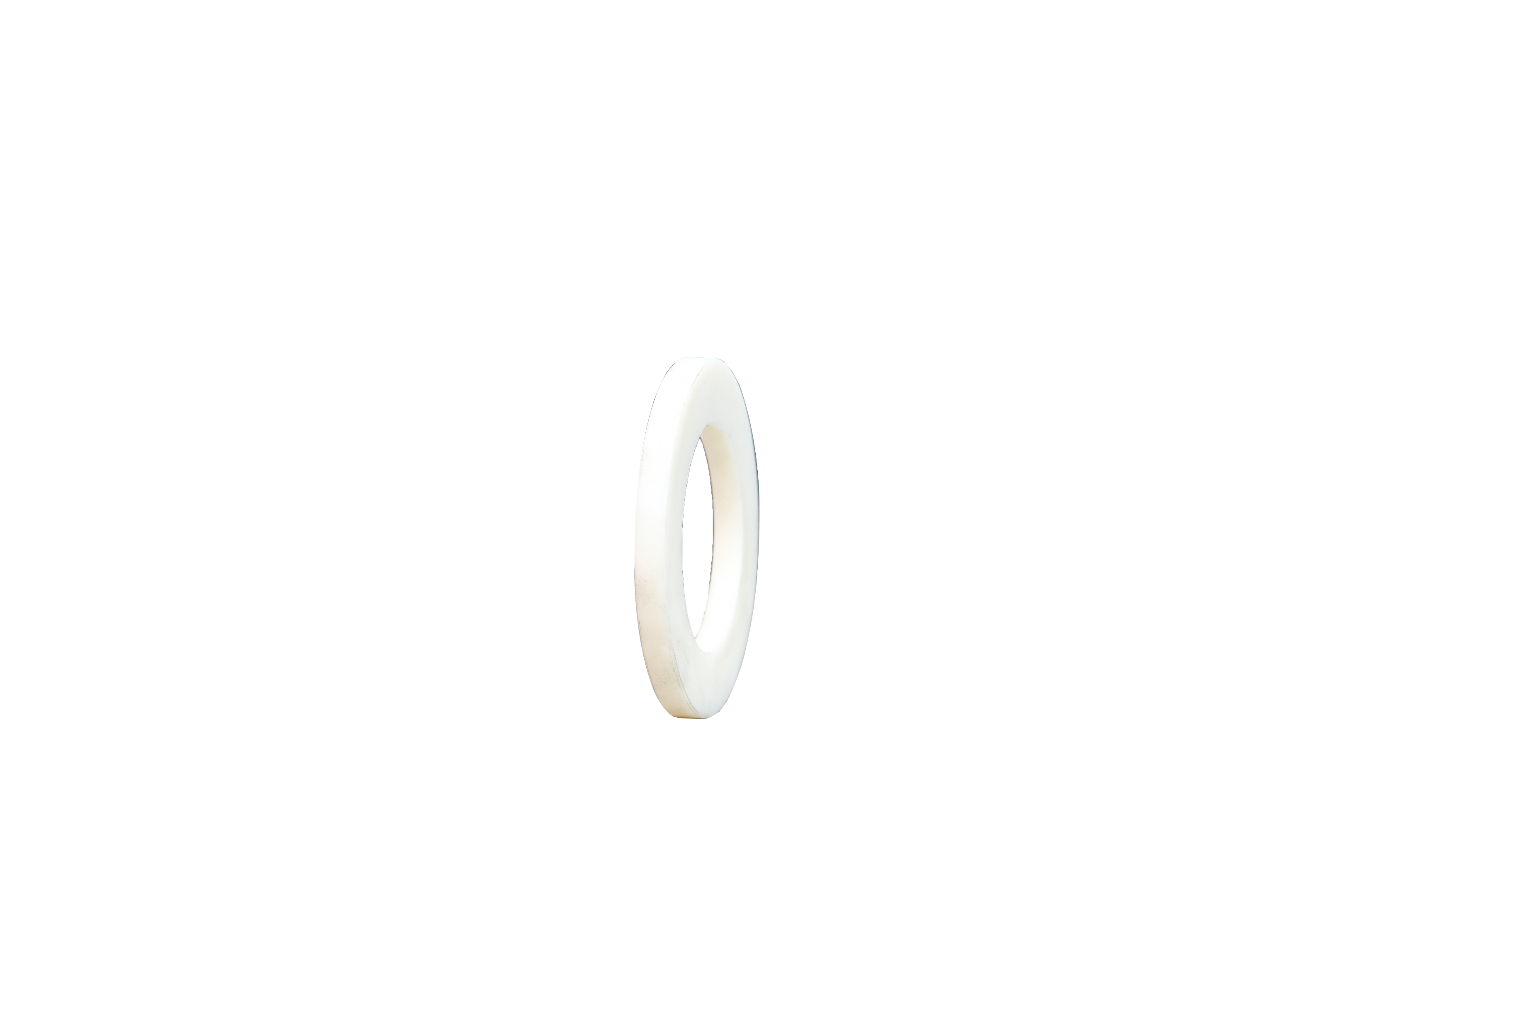

1
2
3
4
4
5
6
7
8
8
8
8
7
9
6
5
4
4
3
2

Number | Part Number | Description
1 | 310114a | Willett Bearing Housing
2 | 310244 | Willett Plastic Spacer
3 | 310164 | Willett Bearing Circlip
4 | 310141 | Willett Bearing U Seal
5 | 310143 | Willett Bearing Plain End
6 | 310142 | Willett Bearing O Ring
7 | 310174 | Willett Nilos Ring
8 | 310163 | Willett Bearing 32015
9 | 310115a 9 inch | Willett Inner Sleeve
 | 310270 | Grease Nipple Tube

